Car Rental System : Drive Your Dreams!!
Sequence Diagram Template

Roll. No. | Gr. No. | Name
22 | 11810820 | Shreya Hirapurkar
58 | 11810499 | Vinayak Kokane
60 | 11810970 | Dhanraj Kore
63 | 11920122 | Vaishnavi Kulkarni

Approvals Signature Block

Project Responsibility | Signature | Date
Project Guide (Internal)
Project Guide (External)
Documentation Leader
The document in this file is for UML Sequence Diagram Documentation Specifications, which conforms to the requirements of UML 2.0.

Items that are intended to stay in as part of your document are in bold; blue italic text is used for explanatory information that should be removed when the template is used.
Table of Contents
1. Sequence Diagram Overview 3
1.1 Scenario Description 3
1.2 Analysis Classes Description 3
2. Message Description 4

1.Sequence Diagram

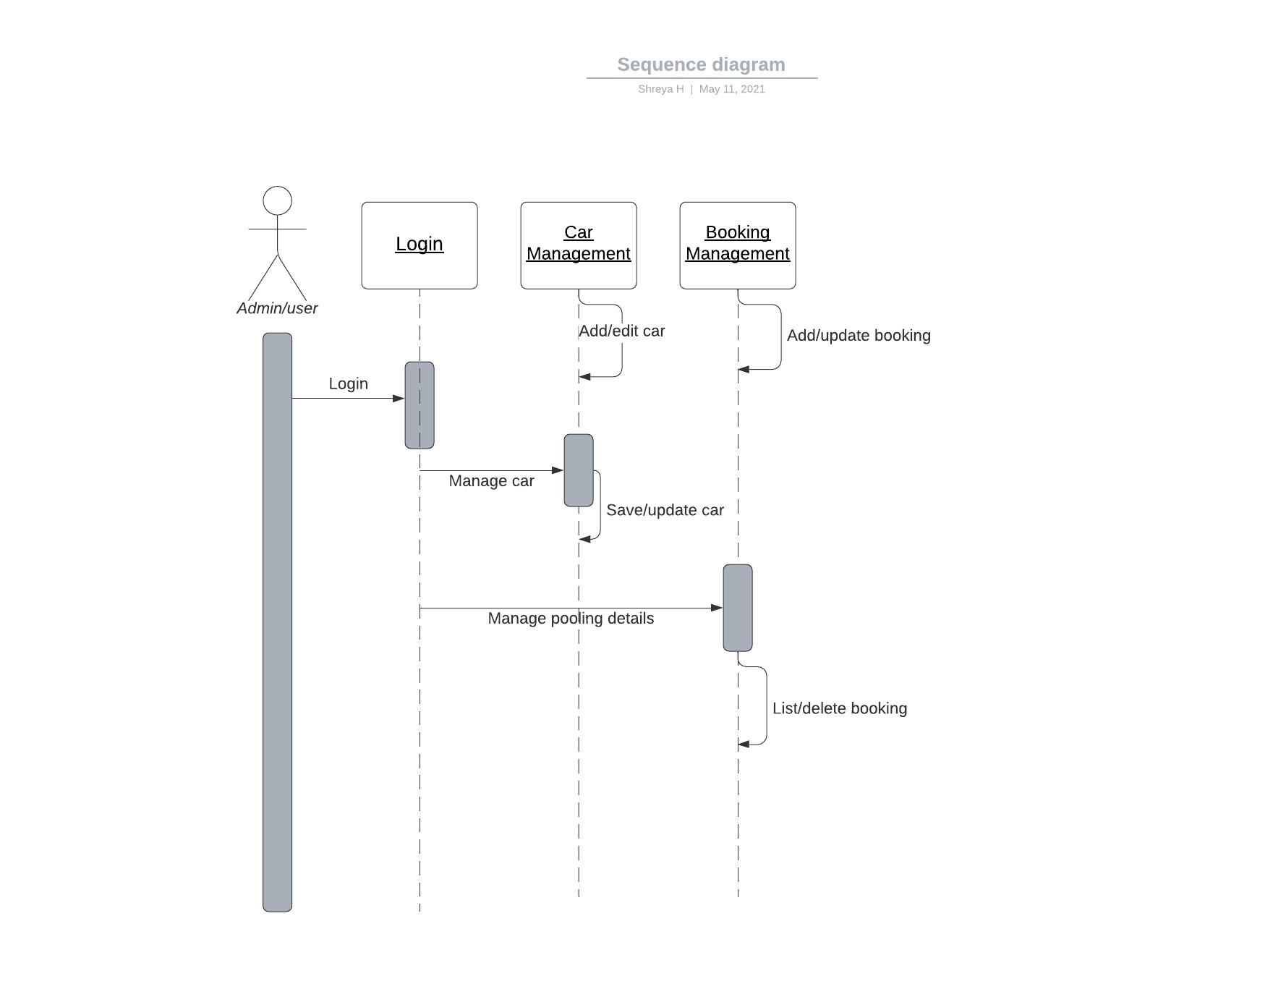

1.1 Sequence Diagram Overview
A sequence diagram simply depicts the interaction between objects in sequential order i.e. the order in which these interactions take place. We can also use the terms event diagrams or event scenarios to refer to a sequence diagram. Sequence diagrams describe how and in what order the objects in a system function. These diagrams are widely used by businessmen and software developers to document and understand requirements for new and existing systems.

Scenario Description
The scenario is described as when the user wants to book a car. He/she will register/login to the system.Then user will check if any car is available as per his/her necessities. If yes,then he/she will check if that car is available for booking on a particular day or not. If yes,he will book a car and the database will be updated.

Informational Item | Information
Use Case | The user visits the system and register/login.
Scenario Name | The user wants to book a car.
Steps | 1.User register/login to the system.  2.Check for a car as per necessities.  3.If available ,then books a car for a particular time on a particular day by making a payment .Database gets updated in this case.

Analysis Classes Description
Main classes of Car Rental System :

Class Name | Purpose
Car | Manage all the operations of cars.
Booking | Manage all the operations of booking.
Car Routes | Manage all the operations of car routes.
Passenger | Manage all the operations of passengers.
Payment | Responsible for making payments via different methods.

Message Description

Message | Type | From Object | To Object
Send message for confirmation | Mail | System | User
Call to ask a query | Call handling | User | Admins
Post review | String message | User | System
Ask a query | String message | User | System

